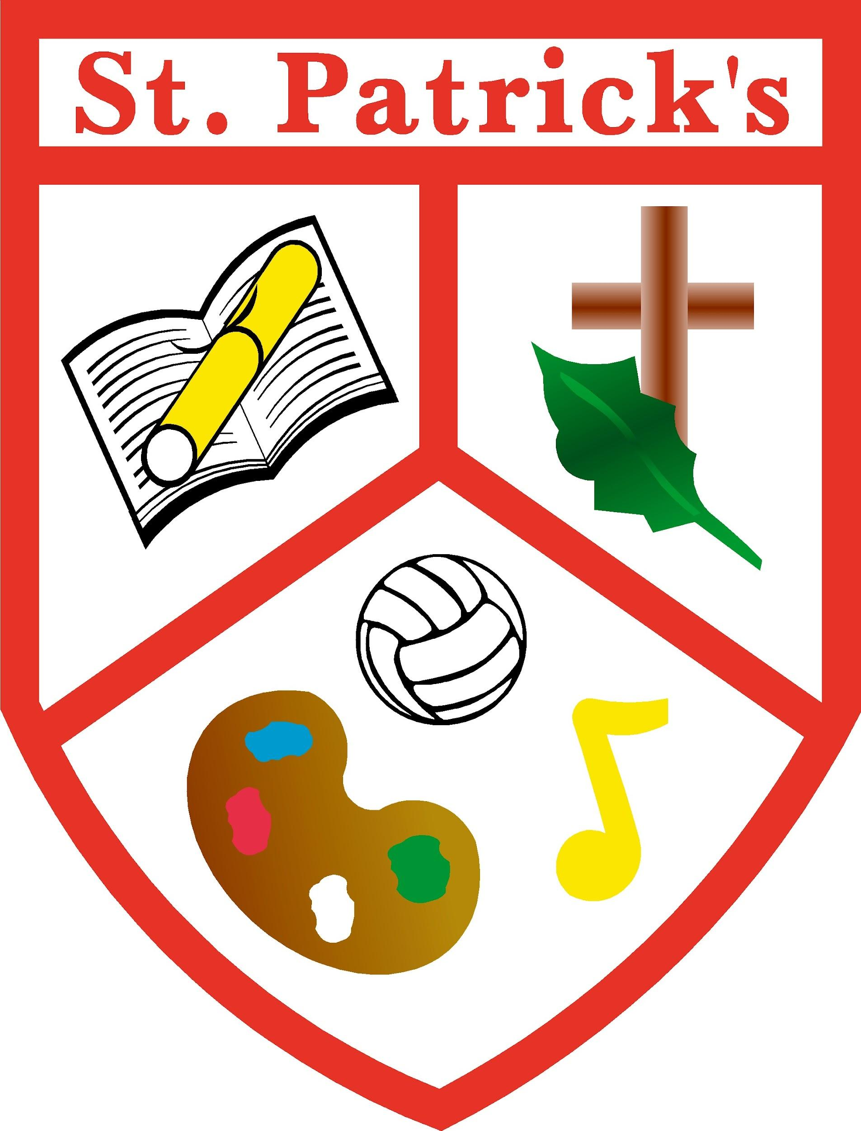

Saint Patrick’s Primary School,

Gilroy Avenue,

Edenderry,

Co.Offaly

Phone/Fax 046 9731478

Email: [office@stpatricksedenderry.ie](mailto:office@stpatricksedenderry.ie)

Website: [www.stpatricksedenderry.ie](http://www.stpatricksedenderry.ie)

Roll Number: 18364O

Register Charity Number: 20132972



*Principal: Ms. Ann Bracken Acting Deputy Principal: Mrs. Yvonne Martin*

**School Calendar 2024 - 2025**

**Term 1**

**Return to School:** Wednesday 28th August

**Halloween break:**Closing: Friday 25th October.

Re-opening: Monday 4th November

**Christmas Holidays:**  Closing: Friday 20th December

**Term 2**

**Return to School** Monday 6th January 2025

**February Bank Holiday:** Closed Monday the 3rd February

**Spring Mid-Term:** Closed Thursday 20th and Friday 21st February

**March Holiday:**  Closed 17th -21st March

Reopening Monday 24th March

**Easter Holidays:**  Closing Friday 11th April.

**Term 3**

**Return to School:**  Monday 28th April

**May Bank Holiday:** Closed Monday 5th May

**June Bank Holiday**: Closed on Monday 2nd June

**Summer Holidays:**  Closing on Friday 26th June